Data-lakes-and-analytics solution

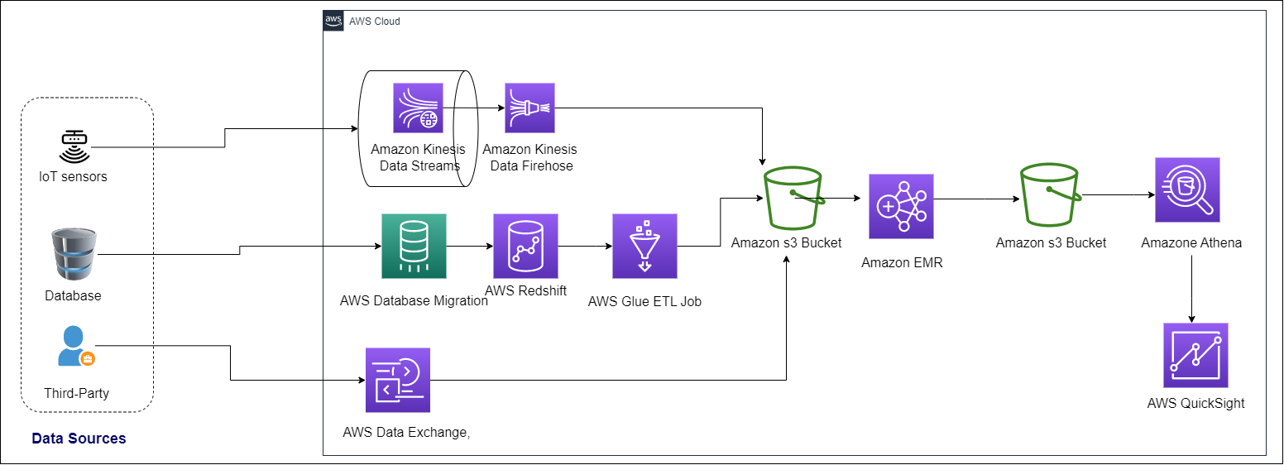

Designing a solution for ingesting and analyzing data from the three different sources into Amazon S3, considering the company's preferences and requirements, we have three data resources.

*1-IoT Sensors Data Ingestion:*

For real-time data ingestion from IoT sensors, you can use Amazon Kinesis Data Streams, which allows you to collect, process, and analyze data in real time. With Kinesis, you can ingest data from thousands of sensors simultaneously and then store it in Amazon S3 for further processing and analysis. You can also use Amazon Kinesis Data Analytics to perform real-time data analytics on the data streams and trigger actions based on the results.

*2-Database Data Ingestion:*

For historical data ingestion from the database, you can use AWS Database Migration Service (DMS), which allows you to migrate data to and from databases such as MySQL, Oracle, and SQL Server. You can also use AWS Glue, a fully-managed ETL service, to extract data from databases, transform it, and load it into Amazon S3 for further analysis.

*3-Third-Party Data Ingestion:*

For supplemental data ingestion from third-party entities, you can use AWS Data Exchange, which is a data marketplace that allows you to discover, subscribe to, and use third-party data in the cloud. With Data Exchange, you can access a wide range of data sets, including financial, consumer, and demographic data, and ingest it into Amazon S3 for further processing and analysis.

Data Cleaning and Transformation:

To clean and transform the data, you can use AWS Glue, which is a fully-managed ETL service that can crawl, catalog, and transform data stored in Amazon S3. Glue allows you to create ETL jobs using Python or Scala, and it integrates with Apache Spark, which is an open-source distributed computing system that supports big data processing.

Dashboard Creation:

To create dashboards that show visual representations of the insights derived from the data, you can use Amazon QuickSight, which is a fully-managed business intelligence service that allows you to create and publish interactive dashboards, reports, and data visualizations. QuickSight integrates with Amazon S3, Glue, and other AWS services, and it supports a wide range of data sources, including spreadsheets, databases, and web services.